**BSC235TE05A MANAGEMENT INFORMATION SYSTEM (L T P C: 3 1 0 4)**

**(For Students admitted from 2023 onwards)**

**Common for B.Sc. (CS) / BCA / B.Sc. (Data Science) / B.Sc. (Cyber Security)**

**COURSE OBJECTIVES**

• To describe the role of information technology and decision support systems in

business.

• To introduce the fundamental principles of computer-based information systems

analysis.

• To enable the students to understand the various knowledge representation methods.

• To enable the students to use information to assess the impact of the Internet and

Internet technology on electronic commerce

• To provide the theoretical models used in database management systems to answer

business questions.

**COURSE OUTCOMES**

• Relate the basic concepts and technologies used in the field of management

information systems;

• Compare the processes of developing and implementing information systems.

• Outline the role of the ethical, social, and security issues of information systems.

• Translate the role of information systems in organizations, the strategic management

processes, with the implications for the management.

• Apply the understanding of how various information systems like DBMS work

together to accomplish the information objectives of an organization.

**SYLLABUS: UNIT – I:** Introduction: Definition of key terms – Management Information, System – Nature and Scope of MIS - Kinds of System; Systems Approach – Classification of MIS **12**

**UNIT – II:** Organization for MIS: Structure for Management; Information requirements at various levels of Management; Manual vs. computerized information system; Data Bank Concept; Types of

Computer-Based /applications **12**

**UNIT – III:** Data Base Management: Meaning of Data-Base; Electronic Data-Base; DBMS – Objectives –Technical Overview – Data Aggregates – Physical and Logical Structures; System Security **12**

**UNIT – IV:** System Development Stages: Investigation, Analysis Design, Construction, Testing,

Implementation, Maintenance **12**

**UNIT – V:** MIS in functional areas of Management: MIS for Marketing, Human Resource, Operations, Finance, General Management – Decision Making. **12 TOTAL: 60**

**TEXT BOOKS**

1. Goyal, Management Information Systems, Managerial Perspectives, Macmillan India

Limited, New Delhi, 2014.

2. Jawadekar, W.S., “Management Information Systems”, Tata McGraw Hill Private

Limited, New Delhi, 2009.

3. Kenneth C. Laudon and Jane P. Laudon: “Management Information Systems” 9/e,

Pearson Education, New Delhi.

**REFERENCE BOOKS**

1. Mahadeo Jaiswal, Monika Mital: “Management Information System”, Oxford

University Press, New Delhi, 2008.

2. Murthy C.S.V.: “Management Information System”, Himalaya Publ, New Delhi, 2008.

3. Panneerselvam R.: “Database Management System”, PHI Private Limited, New

Delhi, 2008.

**Notes**

**UNIT – I:** Introduction:

Whether it is industry, commerce, defense, transport, tourism, banking, education, economics or politics,… updated information is needed everywhere.

exponential growth of information regarding the choice of technology, skill, money and material, competitive products, sales techniques makes it necessary that information is collected, stored and retrieved when needed.

**Definition of key terms:**

**Management:**

**-** has been viewed as be function, a process, a profession and a class of people.

- It refers to the kind of task and activities that are perform by managers.

- The specific nature of the activities is determined by such managerial functions as planning, organising, directing, leadership and controlling.

1. **Planning:** Its objectives in the best possible manner and for anticipating future opportunities and problems. It is the process of deciding in advance the courses of action to be followed and when and how to undertake these.

2. **Organising:** It is formal grouping of people and activities to facilitate achievement of the farm’s objectives. It is need for assigning responsibilities, jobs and hierarchy among personnel.

3. **Controlling:** It is the checking the progress of plans and correcting any deviations that may occur along the way.

4. **Directing:** It is the process of activating the plans, structure and group efforts desired direction. It is needed for implementation of plans by providing desired leadership motivation and proper communication.

**Management Hierarchy:**

* Top management
* Middle or Tactical management
* Junior or Operational management

1. **Top Management:** Establishes the policies, plans, objectives and budget framework under which various departments will operate of the organisation.
2. **Middle Management:** has the responsibility of implementing the policies and overall plans of the top management.
3. **Junior Management**: has the responsibility of implementing day to day operations and decisions of the middle management to produce goods and services to meet the revenue, profit and other goals.

**Information:**

* the data which is organised and presented at a time and place so that the decision-maker may take necessary act as a basis for forecasting
* Data🡪Process🡪Info🡪decision🡪action

**System:**

* System-SubSystem hierarchy is a group of natural or man-made inter-connected elements or components joined together to fulfil certain functions
* Ex: Factory System
  + production subsystem,
    - production control,
    - material control,
      * purchasing,
      * stores,
      * transportation,
      * inspection
    - quality control
  + marketing sub-system,
  + personnel sub-system and
  + financial sub-system.

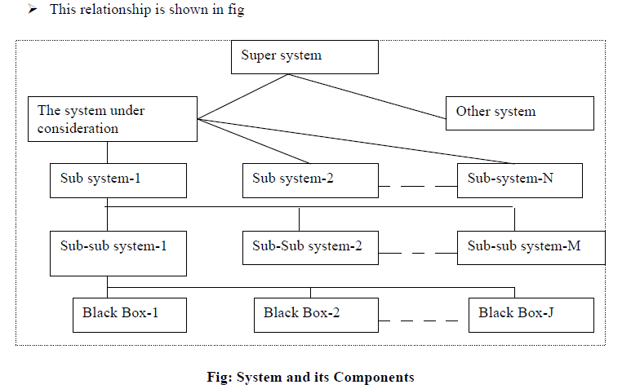

**Definition of MIS:** 1. According to Schwartz, ‘MIS is a system of people, equipment, procedure, documents and communication that collects, validates, operates on transformers, stores, retrieves and present data for use in planning, budgeting, accounting, controlling and other management process’.

2. According to Jerome Kanter, ‘MIS is a system that aids management in making, carrying out and controlling decisions’.

3. According to Davis and Olson, ’MIS is an integrated user machine system designed for providing information to support operational control, management control and decision making functions in an organisation. The information systems make use of resources such as hardware, software, man, procedures as well as suppliers’.

**FRAMEWORK FOR MIS ORGANISATION AND MANAGEMENT TRIANGLE**

Robert Anthony in 1965 suggested that the area of management planning and control can be divided into 3 categories. These are:

 **Strategic planning:** develops the strategy for deciding objectives of the organisation and introducing changes in those objectives, formulating policies to govern procurement, use and disposition of those resources.

 **Management control:** is needed by managers of a various departments to measure the performance, decide on control action, formulate new decision rules and allocate resources.

 **Operational control:** It is the processes of operational activities are carried out to achieve optimum use of resources. It makes use of pre-established procedures and decision rules.

Top, Middle and Junior (TMJ) levels of management responsible for each of these respectively.

The availability of information to management at various levels has improved due to three reasons. **Development of telecommunications, Processing of data with computer, Video technology**

**Information Classification**

1. **Action vs. non-action information**

**2. Recurring vs. non recurring information**

**3. Documentary vs. non documentary information**

4. **Internal vs. external information**

**5. Historical information vs. future projections**:

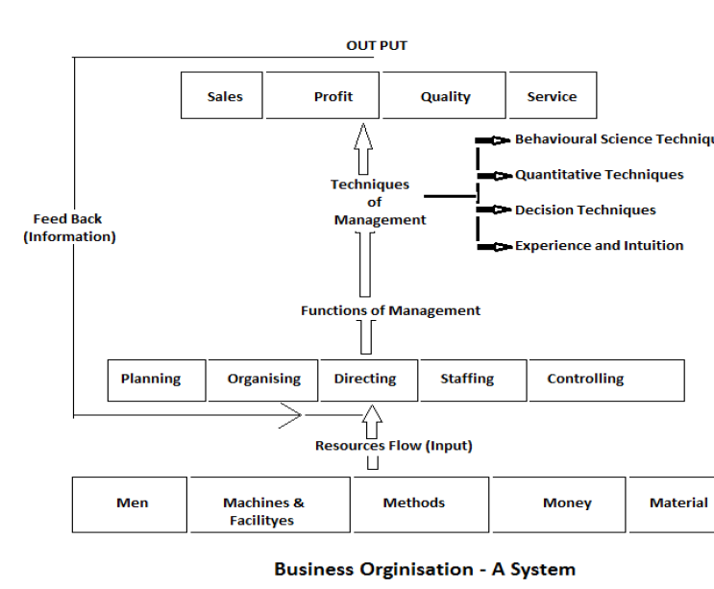

**Classification of systems:**

➢ **The conceptual system** is concerned with theoretical structures which may or may not have any counterpart in the real world. Examples of such systems are economic theory, organization theory, general system of relativity etc.

➢ **Empirical systems** are concrete operational systems made up of people, materials, machines, energy, and other physical things. Other systems such as electrical, thermal and chemical are also fall into this category.

**1. Natural and man-made systems**: The examples of natural systems are: human body, solar system, etc. Examples of man-made systems are: Transportation system, communication system, education system, business organisation etc.

**2. Social system:** A system made up of people may be taken as a social system, such as business organisations, government agencies, political parties, social clubs, professional societies etc.

**3. Man-machine system**: Most empirical systems fall into the category of man-machine systems. One of the examples of this system is aeroplane.

**4. Open and closed systems:**

➢ An open system continually interacts with its environment. This type of system can adapt to changing internal and environmental conditions. Every social and business organization is open because it reacts with its unpredictable environment

➢ A closed system is one of that does not interact with its environment. This system does not change or if it does then a barrier exists between the system and the environment to prevent the system from being affected.

**System life cycle:** A MIS business has the following four phases in its life cycle:

**1. Study phase:** concerned with

1. Identification of the problems

2. Study of the present system and its effectiveness

3. Identification and evaluation of various alternative courses of action

4. Selection of the most appropriate course of action as per the objective.

**2. Design phase:**

1. Identification of the function to be performed

2. Study of the input/output and life cycle design

3. Defining basic parameters of system design.

**3. Development phase:** the decision about the selection and use of hardware and software is taken.

**4. Implementation phase:** The system designed is given practical shape and is adopted for use.

**MEANING AND OBJECTIVES OF MIS**

**➢ Meaning:** MIS is an integrated man-machine system which collects, maintains, correlates and selectively displays information in the proper time frame consistently, to meet the specific needs of various levels of management in order that decisions could be made and action taken for fulfilling the objectives of an organisation.

In other words it is a system which:

i. Provides information to support managerial function. (Planning, control, organising, operating)

ii. Collects information systematically and routinely in accordance with a well-defined set of rules.

iii. Includes files, hardware, software and operations research models of processing, storing, retrieving and transmitting information to the users.

**➢ Objectives:** Facilitate, Provide, Help, Support

**Categories of MIS:** MIS can be subdivided into following four categories:

1. **Transaction processing system (TSP)**: deals with collecting and processing a large volume of data which mainly helps junior level management in discharging their responsibilities.

**2. Information providing system (IPS):** meant for processing information, making a summary of information, and providing exceptional reports.

**3. Decision support system (DSS):** helps in improving the analytical capability of the decision maker by creating interactive model of the real life situation.

4. **Programmed decision-making system**: Programs are simply a string of instruction as to accomplish a job or a task, rather than a person.

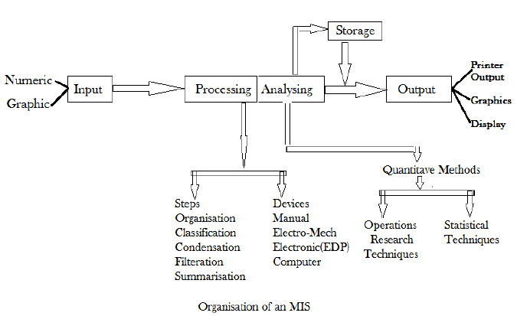

**4 Classification of MIS:**

1. **Data bank information system:** week, just stores/retrieves data for user, not used for any decision making



1. **Predictive information system:** extends data bank system to help specific data report



1. **Decision making information system:** helps with info across system to take decision
2. **Decision taking information system:** to be cautious as this is fully automated like auto replenishment, etc

**Implementation of MIS**

– Nature and Scope of MIS - Kinds of System; Systems Approach – Classification of MIS **12**

**UNIT – II:** Organization for MIS: Structure for Management; Information requirements at various levels of Management; Manual vs. computerized information system; Data Bank Concept; Types of

Computer-Based /applications **12**

**UNIT – III:** Data Base Management: Meaning of Data-Base; Electronic Data-Base; DBMS – Objectives –Technical Overview – Data Aggregates – Physical and Logical Structures; System Security **12**

**UNIT – IV:** System Development Stages: Investigation, Analysis Design, Construction, Testing,

Implementation, Maintenance **12**

**UNIT – V:** MIS in functional areas of Management: MIS for Marketing, Human Resource, Operations, Finance, General Management – Decision Making.